香港中文大學
THE CHINESE UNIVERSITY OF HONG KONG
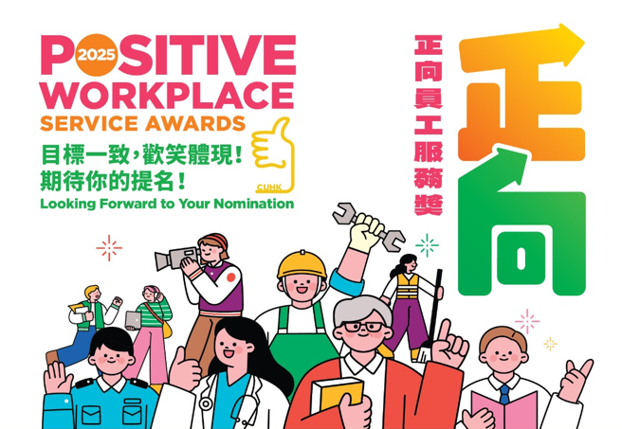
Nomination Form提名表格
Notes備註:
- The information provided on this nomination form will be used by the Committee on Positive Workplace and Staff Development (PWSD Committee) and its Selection Panel(s) [the Panel(s)] for identifying awardees for the Positive Workplace Service and related Awards (the PWS Awards) and promotion of the positive workplace initiatives. 此提名表格內之資料只供大學正向工作間及員工發展委員會和相關遴選委員會為｢正向員工服務獎｣和相關獎項作甄選並推廣正向工作間之用途。
- The nomination form can be completed in either English or Chinese. The completed form together with the supporting documents/materials, if any, should be submitted on or before June 16, 2025 to the Secretariat, PWSD Committee (c/o Human Resources Office, The Atrium, G/F, Lady Shaw Building, CUHK). 此表格可以中文或英文填寫。填妥的表格及有關文件/資料(如適用)須於 2025年6月16日或之前交回正向工作間及員工發展委員會秘書處，地址為香港中文大學邵逸夫夫人樓地下中庭人力資源處。
- Details of the PWS Awards are set out in the Explanatory Document available at the webpage of the Human Resources Office. Enquiries pertaining to the awards can be addressed to Ms. Angel Leung (3943 8611) or Ms. Claire Chan (3943 5514). 有關｢正向員工服務獎｣之詳情，請參閲上載至人力資源處網頁的說明文件。查詢可致電梁安琪女士 (3943 8611) 或陳雯婷女士 (3943 5514)。

Part A: Particulars of the Nominee(s)
甲部: 獲提名員工/團隊的資料
Please select the award category (please as appropriate) 請選擇獎項類別 (請在合適的空格內加):
(For CUHK full-time appointees only 只適用於大學全職僱員)
 | Individual Award個人獎  [please complete part (a) below 請填寫以下(a)部] |  |  | Team Award團隊獎  [please complete part (b) below請填寫以下(b)部]

- Individual Award個人獎
Full Name in Chinese  中文全名: | Full Name in English  英文全名:
Department/Unit  部門/單位: | Position  職位:
Contact Number  聯絡電話: | Email  電郵:
(b) Team Award團隊獎
A work team should be comprised of two or more CUHK full-time appointees who work in the same department/unit or who work on a specific project as an inter-departmental work team. Please list all members of the team in the table below. If additional space is required, please use a separate sheet of paper. 參選工作團隊應由兩名或以上中大全職僱員組成，成員可隸屬同一部門或來自不同部門但參與同一專題工作／項目。請於下表列出各成員的資料，如位置不敷應用，請另加紙張。

Team Name團隊名稱: (English) (中文)

Team Coordinator 團隊聯絡人*:

Contact Number 聯絡電話: Email 電郵:
*(Team Coordinator should be a full-time staff member 團隊聯絡人須為中大全職僱員)

Name in English (Full name)  英文全名 | Position  職位 | Department/Unit  部門/單位

Part B: Recommendation
乙部: 推薦說明

- The positive attributes/contribution of your nominee will be assessed in five criteria, namely: positivity, proactivity, creativity, sustainability, and impact. Separately, the presentation of your recommendation and the provision of relevant supporting materials (e.g. photos, videos and letters of commendation, etc.) carry weight.
參選者的正向素質/貢獻會按五項準則評審，包括正向表現、積極主動性、創意性、可持續性和成果與影響。此外，推薦內容的表達方式和整體質素，包括所提交的參考材料（例如相片、短片及表揚信等）亦非常重要。
- Please read the Explanatory Document on the PWS Awards which provides a detailed description of the assessment criteria and the relevant weightings.
有關｢正向員工服務獎｣獎項的各項評審準則詳情及比重，請參閱相關說明文件。

1. Positivity: Positive Manners and Attitude in the Workplace 工作間的正向表現與態度
2. Proactivity積極主動性
3. Creativity創意性

4. Sustainability 可持續性
5. Impact 成果與影響

Part C: Highlights of the nomination (to be provided by the nominator or nominated appointee/team)
丙部: 提名內容精華 (由提名人或參選同事/團隊提供)
Information provided under Part C below will be promulgated on the PWS Awards’ website to provide a glimpse of the nominations to the University community and to promote the positive workplace culture at the University. Highlights of the previous entries can be viewed at the slideshow of the PWS Awards 2023.
以下丙部提供的資料將會在｢正向員工服務獎｣專頁網站刊登，讓同事們欣賞一眾提名，及促進大學的正向工作間文化。上一屆參選提名的精彩節錄已上載｢正向員工服務獎｣2023網站以供參考。

Please give a brief account (within 80 words) of the nominated appointee/team’s positive attributes and contribution. 請以不多於80字扼要地介紹參選同事/團隊的正向素質及貢獻。
Please share a motto ^{Note} that can best encapsulate the positive energy and spirit of the nominated appointee/team. 請提供一句最能代表參選同事/團隊正能量精神的座右銘^{註}。
^{Note} The motto can be of the nominee’s original creation, or from the famous quotation of the others [in the latter case, please also indicate the source of motto).
^{註} 參選同事/團隊可自行創作相關格言，或引用其他人的創作(如引用他人作品，請指示其出處)。

Part D: Submission of Supporting Materials
丁部: 提交參考材料

As part of the nomination, please submit the relevant supporting materials (e.g. photos, videos, presenting materials and letters of recommendation, etc.) by providing below your o365 OneDrive link with the file(s) uploaded and granted permission. The photos provided may be promulgated on the PWS Awards’ website as part of the entry highlight to promote the positive workplace culture at the University. 作為提名的其中一部分，請提交相關的參考材料（例如相片、短片及表揚信等），並提供已上載參考材料及已開放權限的o365 OneDrive相關連結。此提名所提交的相片將會在｢正向員工服務獎｣專頁網站刊登，成為提名的精彩節錄，宣傳正向工作間文化。

Part E: Particulars of the Nominator
戊部: 提名人資料
I have duly completed this nomination and provided the relevant supporting materials. I hereby declare that I have no personal relations with the nominee(s)/private interest in this nomination. All information provided in this nomination form is complete and true.
謹此聲明本提名並不涉及私交或個人利益，表格亦已填妥，並提交相關參考材料，表格內的資料皆整全無誤。

Full Name in English  英文全名: ___________________________ | Employee ID/Student No.  職員/學生編號: __________________________
Position/Year of Study  職位/年級: __________________________ | Department/Unit  部門/學系: ______________________________
Contact no.  聯絡電話:___________________________ | Email  電郵:___________________________________
Date  日期: _______________________________ | Signature  簽名:___________________________________

